**PES INSTITUTE OF TECHNOLOGY**

**DEPARTMENT OF ELECTRONICS AND COMMUNICATION**

**WIPRO INTERNSHIP PROGRAM -2014**

**Title of the Project :** Audio Effects Processor

|  |  |  |
| --- | --- | --- |
| **Name** | **USN** | **Dept , Section** |
| Akash R Vasishta | 1PI12TE009 | TE , ‘A’ |
| Manoj K | 1PI12TE055 | TE , ‘A’ |
| Preetham Kulai | 1PI12TE072 | TE , ‘B’ |
| Sumukh Desu | 1PI12EC117 | EC , ‘B’ |

**Objective:**

Our main aim here is to create an interactive, cost effective audio effects processor using OMAP 3530 along with an unique user interface using the touch panel. We want to bring out the new concept of audio signal processing using hardware components. Unlike the software process ( like using matlab) this method doesn’t not give any latency while adding the effects. We plan to implement various audio effects like echo, flanger, tempo and reverberation along with some additional features.

**Abstract:**

Audio signal processing is the intentional modification of sound signals through an effects unit for the hearing benefit of the user. Software audio effects processor are flexible and can generate various effects as a user needs. But when it comes to performance, the current software processors are not that efficient when compared to that of a hardware unit[1]. The traditional software approach to digital signal processing often introduces an unacceptable delay between the audio input and the audio output also called latency. This will be a problem in case of real time operation such as live processing of musical instruments [2].

As audio signals may be electronically represented in either digital or analog format, signal processing may occur in either domain. Analog processors operate directly on the electrical signal, while digital processors operate mathematically on the digital representation of that signal. Digital signal processing is done by the processing of digitized discrete time sampled signals. Processing is done by the OMAP processor [3].

**Technical details of existing systems:**

At present, many audio effects processors are available. The BR-800 effects processor[4] by BOSS is one such system.

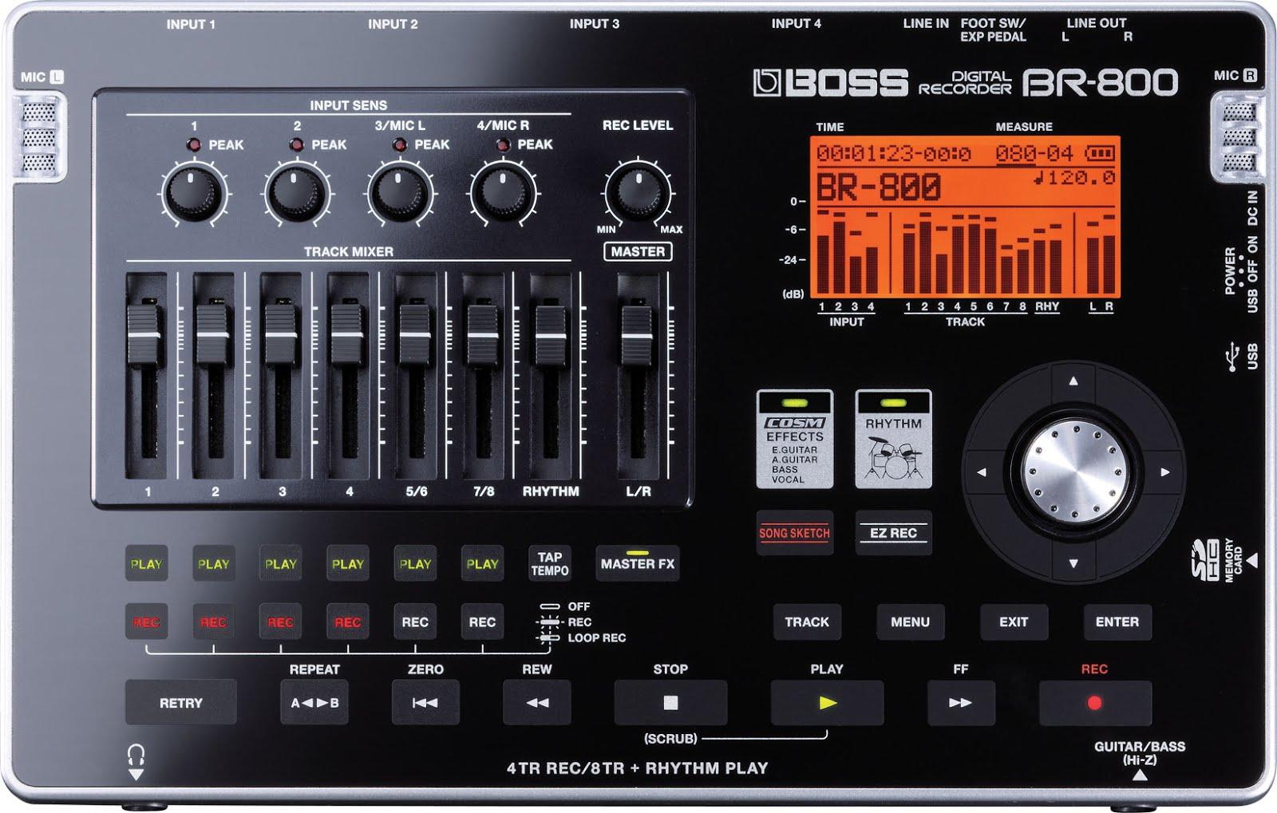

* Sample rate : 44.1KHz
* Frequency response : 20 to 20000 Hz
* 24 bit ADC
* 24 bit DAC
* Nominal Input level : -10 dB
* Nominal Output level : -10 dB
* 128 x 64 dots (Backlit LCD) display
* Power Supply : 9V DC, AC adapter, USB bus power
* SD Card Compatibility : 1 GB - 2 GB
* 4 Input Jacks
* Battery Life : 5.5 hours
* Display : 128 x 64 dots (Backlit LCD)

**Specifications of our system:**

* OMAP 3530
* PMIC (TPS65930)
* Class-D amplifier (TPA2010D1)
* Stereo Jack (SJ1-3535NG)
* 24 bit RGB 3.5 inch LCD
* Touch controller (TSC2046)
* Sample rates of 8, 11.025, 12, 16, 22.05, 24, 32, 44.1, 48 (in KHz)
* 2 channels (Mono and Stereo)
* Speaker gains in the range -50 to 12dB with 2dB step

**Implementation:**

Every audio signal is represented in digitized discrete time samples taken depending on the frequency. These samples are stored in a buffer and manipulating this buffer is called digital signal processing.

Basic operations like addition, multiplication, division are performed on these samples to produce different effects.[5]

Echo production: To produce echo we need to delay the original signal by some time by adding a few blank samples and then divide them by a constant to reduce its amplitude. Then this delayed, lesser amplitude signal is added to the original signal and played. This produces an echo.

Flanger effect: A flanger creates a "jet plane" or "spaceship" sound, simulating a studio effect produced by recording a track on two synchronized [tapes](http://en.wikipedia.org/wiki/Reel-to-reel_audio_tape_recording) and periodically slowing one tape. When the two tapes' [audio signals](http://en.wikipedia.org/wiki/Audio_signal) are later mixed, a [comb filter](http://en.wikipedia.org/wiki/Comb_filter) effect can be heard [6].

Tempo production: Fast forwarding is produced by playing the same audio sample in a much lesser time. i .e increasing the playback speed of the audio.

Slow motion is produced by playing a percentage of the audio data in the same time interval as that of the original.

**Alternative solutions:**

Basically there are two ways to produce audio effects. The software way like the Audacity and the hardware way.

There are existing hardware systems which use FPGA based processor to produce audio effects.

This is the same as the OMAP based audio processor which we are implementing. Since OMAP is basically a high- performance multimedia application platform.

**Testing methods:**

We plan to test it by making the user record a song which is stored in the buffer. Once that is done, we will ask the user to input the effect he wants ie. echo, flanger, filter or reverb. Depending on their choice, the program in the ULK board automatically chooses the required effect and manipulates the song stored in the buffer in order to get the required effect. Now the song is played in the L & R speakers to get the specified effects.

We plan to conduct various test cases in order to test our program. We would be doing so by recording and moving different songs into the buffer. We plan to choose songs of different pitches, loudness, beats and various other parameters. After recording these songs one by one, it is moved to the buffer and then tested for the 4 effects ie. echo, flanger, filter and reverb by manipulating each effect and changing the generalisation made for all songs earlier.

We plan to input various conditions in order to smoothen out the applied effects for any song and plan to keep the test cases going until we have come to a proper conclusion.

**References:**

[1] [Stefania Serafin](http://www.media.aau.dk/~sts). Audio effects. Available: <http://www.media.aau.dk/~sts/ad/effects.html>

[2] Multiple authors.(13 March 2014). Audio signal processing. Available: <http://en.wikipedia.org/wiki/Audio_signal_processing>

[3] M Waqas Khan. (2012, December 5) FPGA based audio processing. Available: <http://zeekscamz.blogspot.in/2012/12/fpga-based-audio-processing.html>

[4] BR-100 audio processor, BOSS,Available: <http://www.bossus.com/gear/productdetails.php?ProductId=1068&ParentId=325>

[5]B[ryhoyt](http://dsp.stackexchange.com/users/2076/bryhoyt).(2012, Oct 7).Mixing audio signals.Available:

<http://dsp.stackexchange.com/questions/3581/algorithms-to-mix-audio-signals-without-clipping>

[6]Mike Hudson. (2012, June 11). FPGA based audio processor. Available:

<http://jugglingpirate.net/final-year-project-electronics/>